

Green University of Bangladesh

Department of Computer Science and Engineering (CSE)

**Faculty of Sciences and Engineering**

**Semester: (Spring, Year:2023), B.Sc. in CSE (Day)**

**LAB REPORT NO #03**

**Course Title: Engineering Drawing Lab Course Code: CSE-208 Section: PC213DA**

**Lab Experiment Name: 2D Floor Planning**

**Student Details**

|  |  |  |
| --- | --- | --- |
| **Name** | | **ID** |
| **1.** | **Pankaj Mahanta** | **213902002** |

**Lab Date : 09-05-2023**

**Submission Date : 15-05-2023**

**Course Teacher’s Name : Rusmita Halim Chaity**

**[For Teachers use only: Don’t Write Anything inside this box]**

**Lab Report Status Marks: …………………………………**

**Comments: ..............................................**

**Signature: .....................**

**Date: ..............................**

1. **TITLE OF THE LAB EXPERIMENT**

In this lab experiment I will draw a design using all necessary 2D tool such as circle, offset, line, diameter, trim, Block and 2D floor plans and so on.

1. **OBJECTIVES/AIM [ mark]**

In this problem my main goal is how to draw the main shape of the all room design firs. I used the line tool drawing all necessary rectangle shape as well as.

1. **PROCEDURE / ANALYSIS / DESIGN [3 marks]**

In this section, I will handle how to complete my design and which tool are needed in this experiment. First of all, I use the line and offset tool with a very important part is the offset because most of the time use this tool in this experiment. I use a line tool to make a rectangle whose breath is 38 feet and height is 29 feet 2 inches.

Secondly, I use the line tool for the toolbar and make a draw with a line inside the rectangle with a drawing the upper part of the design which is Kitchen and dining room. Which size is 14 feet 4 inches and 12 feet 4 inches. Then drawing a Bath which length is 5 feet then drawing 5 feet Then drawing 13 feet 8 inches and 12 feet bedroom.

The third time I use the offset tool whose offset value is large part is 10 inches and another offset value is 4 inches and other part is value import part is draw a Window and Door which is very important part of the 2D Floor Planning Design. In this design I draw a Door which size is 2 feet 4 inches then I convert this shape to Block from Block tools. Then I draw a Window which size is different because in this floor planning design I have taken 3 size Windows first size is 2 feet 4 inches and second is 5 feet 6 inches and Third is 3 feet 4 inches.

Finally, I draw the Block shape which is the block part using the built-in block shape such as Kitchen part , Bath part and so on.

1. **IMPLEMENTATION [3 marks]**

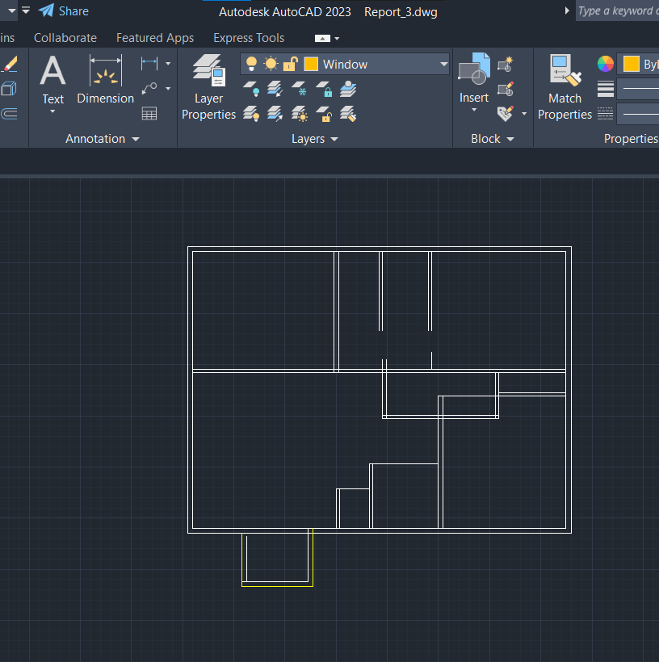

**Figure-:1.1**

First of all, I use the line and offset tool with a very important part is the offset because most of the time use this tool in this experiment. I use a line tool to make a rectangle whose breath is 38 feet and height is 29 feet 2 inches. All important part for 2D floor plan design.

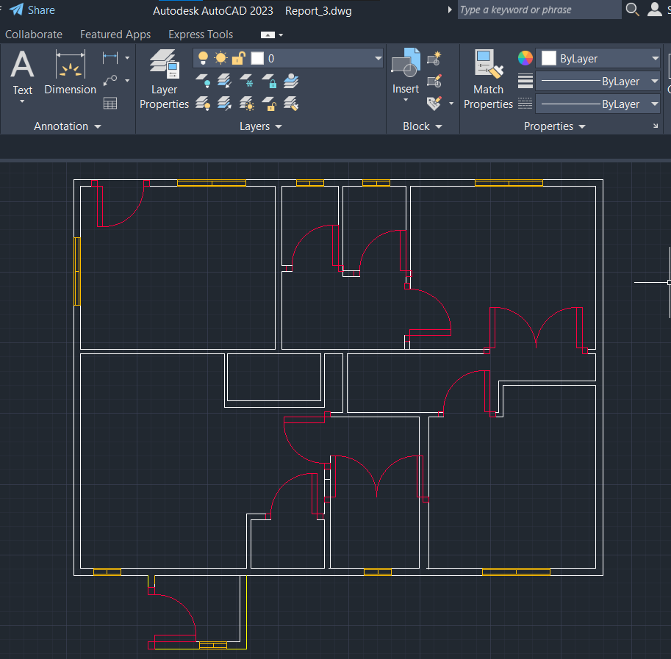

Figure-:1.2

In this section figure-1.2 I Secondly, I use the line tool for the toolbar and make a draw with a line inside the rectangle with a drawing the upper part of the design which is Kitchen and dining room. Which size is 14 feet 4 inches and 12 feet 4 inches . Then drawing a Bath which length is 5 feet then drawing 5 feet Then drawing 13 feet 8 inches and 12 feet bedroom And others part which is unnecessary trim it and I setup the windows and Doors for necessary position.

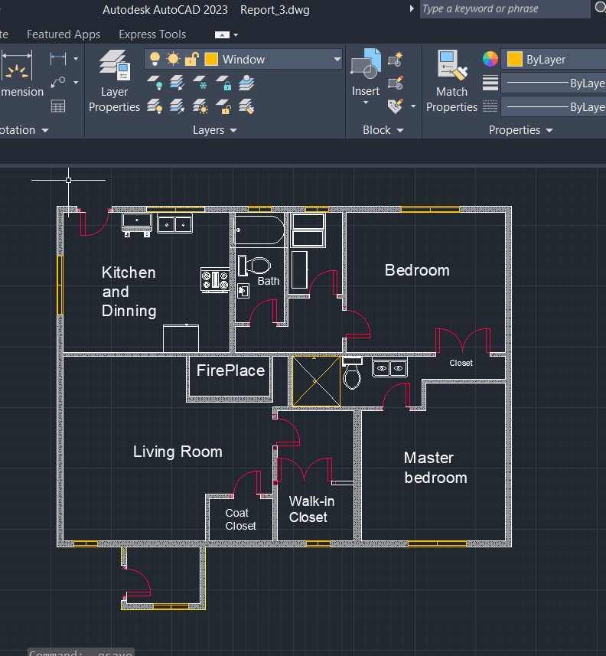

Figure-:1.3

In this section, I use the trim tool to trim all unnecessary parts and find this figure. In this figure 1.3 draw an important part which is the using the Hash part for the wall part and specific the name of the all room. And copy and paste the necessary objects from the Blocks part.

1. **TEST RESULT / OUTPUT [3 marks]**

**Output:**

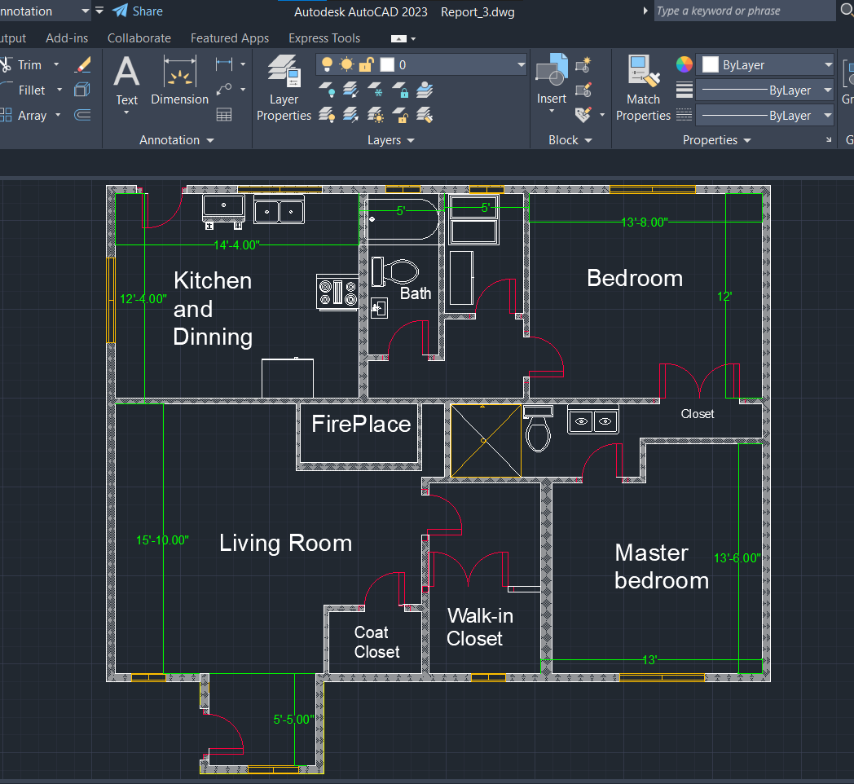

Figure-:2

1. **ANALYSIS AND DISCUSSION [3 marks]**

In this section, I complete my design easily but only one part I do not understand which is the block shape I can not find it in the Block panel I download some block shapes from google then import them and use them. Then my second problem is I do not understand the opacity used in wall Then I find it is the hash tool used it finally.

1. **SUMMARY**

This section will state a description of the goals of the given problem. My first goal is to draw a line and use an offset tool then draw a rectangle then I will find the final output of my experiment